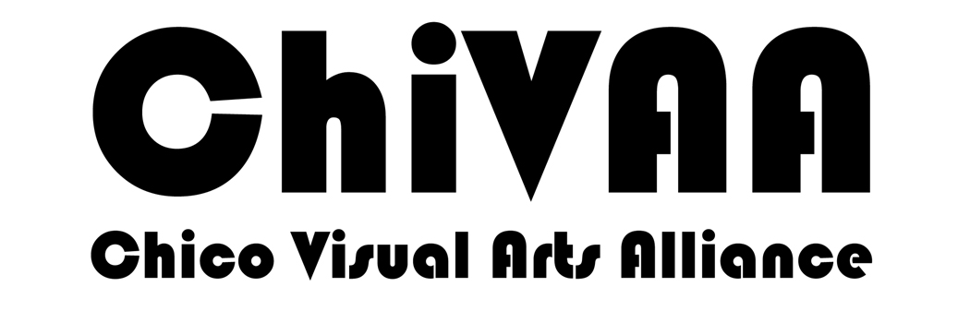
530-318-2105

ChiVAA, the Chico Visual Arts Alliance, is an umbrella organization that links individual artists and art groups, organizations or businesses, enabling them to have a united voice and presence in Chico.

ChiVAA, Inc. Mission Statement
The mission of ChiVAA is to foster an environment in which artists and visual arts stakeholders may flourish in order to enhance the cultural and economic well-being of the larger community.

Membership is from July 1st to June 30. Members will have immediate access to a listing on the ChiVAA website (www.chivaa.org) and a listing on the subsequent edition of the printed and online Chico Art Map.

PLEASE EMAIL YOUR INTEREST IN MEMBERSHIP
info@chivaa.org or go to www.chivaa.org and
then go to the Membership Page

Membership is from July 1 to June 30.

Membership benefits include

- Listing on the Chico Art Map
- Listing (images, statement, links) on ChiVAA website. To be included, send your info to webmaster@chivaa.org
- Reduced rate for Art at the Matador
- Annual Meeting
- Publishing and receiving e-news bulletins with calls for art, invitations to openings, and marketing opportunities
- Periodic reports of the Chico Arts Commission meetings
530-318-2105

Name Phone_______

Street Address City Zip

E-Mail/Website

Check your particular category below. This determines how and where you are listed on the Chico Art Map, online Chico Art Map and website.

[ ] Individual Artist/Studio Membership
[ ] Businesses, Art Gallery, Commercial Art Organizations
[ ] Supporter (your donation will be acknowledged as a tax deductible donation but will remain anonymous unless you choose to be a sponsor for some of our events)
[ ] Hours open to public (if applicable)
[ ] Public Listing: [ ] Art Map [ ] ChiVAA Website
To be included, send images, statement, links to webmaster@chivaa.org

Please pay online on our website at http://chivaa.org/membership/
or send a check in the amount indicated below to:
ChiVAA, P. O. Box 1967, Chico, CA 95927

[ ] $30 [Individual Artist/Studio Membership]

[ ] $50 [Business Membership]

[ ] No Charge [Non-Profit Organization]

[ ] ______ Any Amount [Supporter: Individual or Business Donation]

[ ] Yes, I want to be an official sponsor

Please also email your information to: info@chivaa.org

